**In-class exercise: CSC3054/7054**

**14/03/2016**

1. In the Android system architecture, we have five main components: Application, application framework, libraries, Android runtime and Linux kernel. (1) ‘Core libraries’ belong to the component ‘libraries’, (2) ‘view system’ belong to the component ‘applications’, and (3) ‘power management’ belongs to the component ‘application framework’. Which statement is correct and which one is not correct? (3 marks)
2. In the “Hello Android” Android app, what are the roles of “activity_main.xml” and “MainActivity.java”? (2 marks)
3. Please explain the code indicated as {explain this code} in the following snippet of code extracted from “MainActivity.java” of the “Hello World” Android app. (2 marks)

public class MainActivity extends Activity {

@Override

protected void onCreate(Bundle savedInstanceState) {

super.onCreate(savedInstanceState); {explain this code}

setContentView(R.layout.*activity_main*);

}

@Override

public boolean onCreateOptionsMenu(Menu menu) {

getMenuInflater().inflate(R.menu.*main*, menu);

return true;

}

}

1. Steve has been asked to design an Android sensory measurement app in order to monitor the changes of the orientation sensor and accelerometers. When the changes have been detected, the sensory value will be displayed on the screen. The following code is a snippet of code extracted from “activity_main.xml”. In Figure 1, which image (please choose (a) or (b)) is related to the output of the code shown below? Why? (2+2=4 marks)

<?xml version=*"1.0"* encoding=*"utf-8"*?>

<TableLayout xmlns:android=*"http://schemas.android.com/apk/res/android"*

android:layout_width=*"fill_parent"*

android:layout_height=*"fill_parent"*

android:stretchColumns=*"2"*>

<TableRow>

<TextView

android:id=*"@+id/accelerometer_label"*

android:layout_column=*"1"*

android:text=*"Accelerometer"*

android:textSize=*"9pt"*

android:padding=*"3dip"* />

</TableRow>

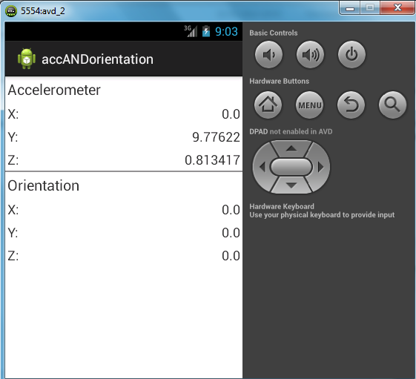 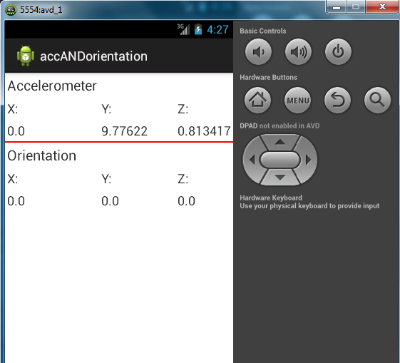

1. (b)

Figure 1 Layout of accelerometer and orientation.

1. Steve continues to write code for the Android sensory measurement app. The following snippet of code is extracted from “MainActivity.java”. Please point out the places that contain errors and then explain why they are incorrect. (2+1+1=4 marks)

@Override

protected void onResume() {

.onResume();

sensorManager.registerListener(it, sensorManager.getDefaultSensor(Sensor.TYPE_ACCELEROMETER), SensorManager.SENSOR_DELAY_NORMAL);

sensorManager.registerListener(it, sensorManager.getDefaultSensor(Sensor.TYPE_ORIENTATION), SensorManager.SENSOR_DELAY_NORMAL);

}

1. What are the debugging techniques available in Android? (2 marks)
   1. DDMS;
   2. Breaking points;
   3. Memory profiling;
   4. All of the above;
   5. None of the above.
2. The following code comes from AppWidget.java of the home-screen widget application (for Toggle Silent Mode). Can you correct all the errors in this code? (2 marks)

private RemoteViews buildUpdate(Context context) {

RemoteViews updateViews=new RemoteViews(context.getPackageName(),R.layout.widget);

AudioManager audioManager = (AudioManager)context.getSystemService(Activity.AUDIO_SERVICE);

if(audioManager.getRingerMode() == AudioManager.RINGER_MODE_NORMAL) {

updateViews.setImageViewResource(R.id.phoneState, R.drawable.phone_state_normal);

audioManager.setRingerMode(AudioManager.RINGER_MODE_NORMAL);

} else {

(Other code is omitted here)}

1. Someone is creating a Google Maps app. In the “MainActivity.java” code, he uses the SupportMapFragment class to create a fragment. To load the Google Map, which of the following answers is correct to embed maps as a fragment with a XML snippet? (2 marks)
   1. findById();
   2. findFragmentById();
   3. getContext.findFragmentById();
   4. getSupportFragmentManager().findFragmentById().
2. I want to generate an app with two buttons “Start” and “Finish” and show them on the Emulator. The following code is a snippet of code extracted from “activity_main.xml” of the project. Could you help me to finish it (you can name anything for the id)? (2 marks)

<Button

android:layout_width=*"98px"*

android:layout_height=*"wrap_content"*

android:text=*"Start"*

android:id=*"{add code here}"*>

</Button>

<Button

android:layout_width=*"98px"*

android:layout_height=*"wrap_content"*

android:text=*"Finish"*

android:id=*"{add code here}"*>

</Button>

1. Why do we have to declare a class “public class MainActivity extends Activity” in an app project? (2 marks)
2. Describe the roles of major classes and UI components used in the “MainActivity.java” code of the Silent Toggle Mode app that has the layout as shown on Figure 2. (5 marks)

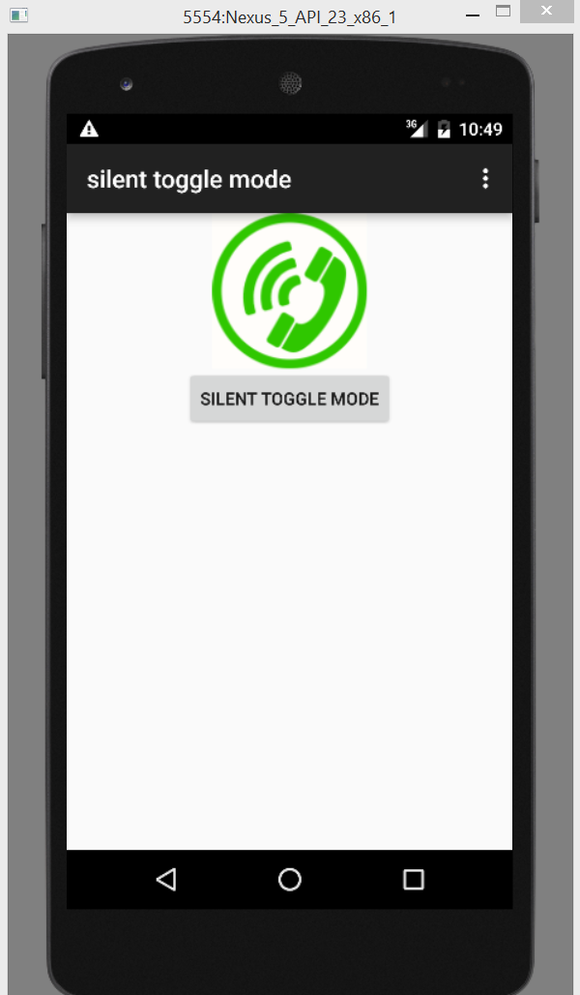

Figure 2 Layout of Silent Toggle Mode app.